Our model has 3 main sections: Drivers, Customers and Rides. It is composed of 15 tables out of which 4 are associative tables. Will take a closer look at each of the sections and their respective tables.

SECTION 1; Drivers Tables Breakdown

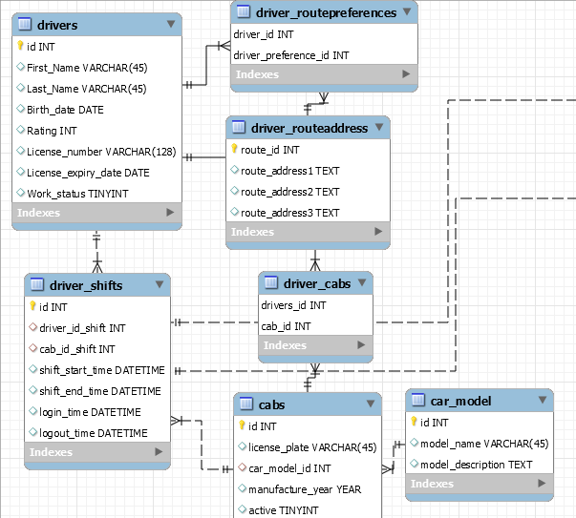

1. Drivers

This table contains all pertinent attributes about driver’s personal information and special attributes required by the employer.

* Id INT: **Primary Key**; ID number to uniquely identify each driver.
* First_Name VARCHAR(45): First name of driver
* Last_Name VARCHAR(45): Last name of driver
* Birth_date DATE: Date of birth of driver
* Rating INT: Average customers rating of driver
* License_number VARCHAR(128): This is an ID number (unique in nature as issued in the real world) or alphanumeric code for a government-issued license of each driver.
* License_expiry_date DATE: Date when drivers’ license permit expires.
* Work_status TINYINT: Status of driver, currently working or not. This is supposed to be a Boolean value (1/0) that would be changed based on when the driver logs on and off the system.

1. Drivers_shifts

This table contains information of actual working hours and the scheduled shifts for cars and drivers. Each shift will have atleast one cab and driver.

* id INT: **Primary Key**; a unique shift ID number
* driver_id_shift INT: **Foreign Key**; this is a reference to the drivers table and provides information about driver’s shifts by driver’s ID
* cab_id_shift INT: **Foreign Key**; this is a reference tothe cabs table and provides information about cabs associated with shifts by cab’s ID
* shift_start_time DATETIME: Date and time of the start of shifts.
* shift_end_time DATETIME Date and time of the end of shifts.
* login_time DATETIME: Date and time of login at the start of shifts.
* logout_time DATETIME: Date and time of logout at the end of shifts.

3) Driver_routepreferences

This table functions as an associative table and connects each driver to their respective route preferences. As M drivers can have N route-preferences, the model is designed using this associative table to keep a record of each driver’s preferences. While each driver having multiple route preferences can change their route preferences several times therefore a unique route ID can be assigned to the same driver. Therefore, to avoid duplication of driver_id records in the drivers table, this associative table is used to keep track of their route-preferences.

* driver_id INT : **Primary Key & Foreign Key**; This is a unique ID number for this table as well as a reference to the Drivers table, and describes the driver’s ID number which is a primary key in the drivers table.
* driver_preference_id INT: **Primary Key & Foreign Key** This is a unique ID number for this table as well as a reference to the driver_routeaddress table, and describes the Route_id number which is a primary key in the that table.

4) Driver_routeaddress

This table lists the specific route preferences of drivers based on their route_id.

* route_id INT: **Primary Key**; a unique route ID
* route_address1 TEXT: Drivers first route preference. The datatype is TEXT as the addresses might vary in length.
* route_address2 TEXT: Drivers second route preference
* route_address3 TEXT: Drivers third route preference

5) Driver_cabs

This table functions as an associative table and connects each driver to their respective cabs. As M drivers can have N cabs, the model is designed using this associative table to keep a record of the cabs used by each driver.

* drivers_id INT: **Primary Key & Foreign Key**; This is a unique ID number for this table as well as a reference to the Drivers table, and describes the driver’s ID number which is a primary key of that table.
* cab_id INT: **Primary Key & Foreign Key**; This is a unique ID number for this table as well as a reference to the cabs table and describes cabs unique identification number.

6) Cabs

This table contains all pertinent information about cars used for this cab service.

* id INT: **Primary Key**; cabs unique identification number
* license_plate VARCHAR(45): license plate number of the cab.
* car_model_id INT: **Foreign Key**; this is a reference to the car_model table and describes car model information.
* manufacture_year YEAR: car’s year of manufacturing
* active TINYINT: status of car, whether or not the taxi service is still using the car.

7) Car_model

This table contains information about each cars description.

* Id INT: **Primary Key**; car models unique identification number
* Model_name VARCHAR(45): name of model of car
* Model_description TEXT: description of car model

Section 2: Cab Ride Tables Breakdown

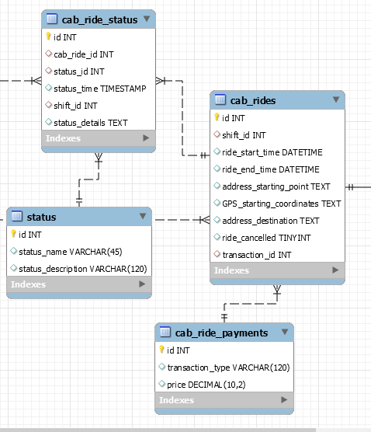

1. Cab Rides

This table contains all information about a cab ride including shifts(which further contain the driver’s information), cab and customer information.

* Id INT- **Primary key**: Unique ID attached to a specific cab ride
* Shift_id INT- **Foreign key**: This is a reference to the Drivers_Shift table and provides us information on a specific driver’s shift information for a specific cab ride .
* Ride_start_time DATETIME: Indicates the time a cab ride began
* Ride_end_time DATETIME: Indicates the time a cab ride ended
* Address_starting_point TEXT: Displays the address where the passenger was picked up
* GPS_starting_coordinates TEXT: Displays the GPS coordinates of where the passenger was picked up
* Address_destination TEXT: Displays the address of the passenger’s destination
* Ride_cancelled TINYINT: Indicates if a ride was cancelled
* Transaction_id INT- **Foreign key**: This is a reference to the Cab_Ride_Payments table and provides us information on the transaction details of a specific cab ride

1. Cab Ride Status

This table connects the cab ride information and the status of the ride.

* Id INT- **Primary key**: Unique ID attached to a specific cab ride status.
* Cab_ride_id INT- **Foreign key**: This is a reference to the Cab_Rides table and provides us information on the specific cab ride
* Status_id INT- **Foreign key**: This is a reference to the Status table and provides us information on the status of a specific cab ride
* Status_time TIMESTAMP: Time that the status of the cab ride came into effect
* Shift_id INT- **Foreign key**: This is a reference to the Driver_Shifts table and provides us information on a specific driver’s shift information for a specific cab ride
* Status_details TEXT: Additional details regarding the status of a specific cab ride

1. Status

This table describes the status of the cab ride; whether the ride is active or not.

* Id INT- **Primary key**: Unique ID attached to the status of a specific cab ride
* Status_name VARCHAR(45): Indicates the name that a status can be for a ride (i.e. “new ride”*,*“ride assigned to driver”*,*“ride started”*,*“ride ended”*, or*“ride canceled”.etc.)
* Status_description VARCHAR(120): Provides a description of the current status (i.e. en route to destination)

1. Cab Ride Payments

This table contains information on the price and payment for cab rides.

* Id Int- **Primary key:** Unique ID attached to a transaction for a specific cab ride.
* Transaction_type VARCHAR(120): Type of payment used for transaction (i.e. cash or card)
* Price DECIMAL(10,2): Total cost of a specific cab ride

Section 3 - Customer Tables Breakdown

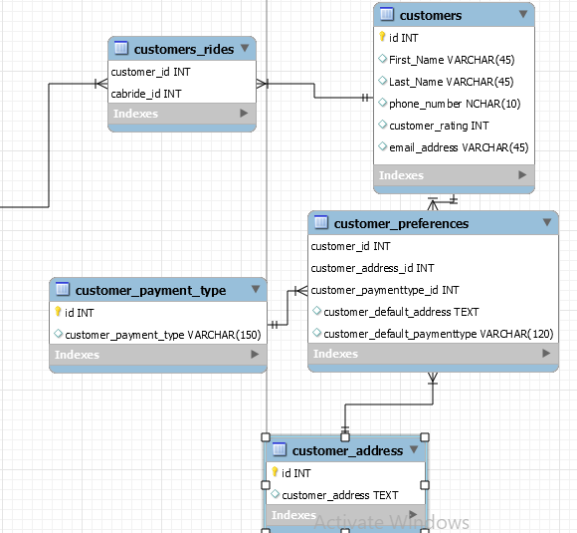

1. Customers

This table contains all pertinent information associated with a customer identification.

* Id INT – **Primary Key:** This field is used to store a unique ID that is assigned to each customer.
* First_Name VARCHAR(45): This field is used to store each customer’s first name.
* Last_Name VARCHAR(45): This field is used to store each customer’s last name.
* Phone_number NCHAR(10): This field is used to store each customer’s phone number.
* Customer_rating INT: This field is used to store a rating that is assigned to each customer by the organization or drivers.
* Email_address VARCHAR(45): This field is used to store each customer’s email address.

1. Customer_rides

This table associates the cabride information with the customer information. M customers can take N rides and therefore to store each cab ride record taken by these customers and avoid duplicating the primary key in the customers table, this associative table is used.

* Customer_id INT – **Primary Key,** **Foreign Key**: This is a unique ID number for this table as well as a reference to the Customers table and is used to store a unique ID that is assigned to each customer.
* Cabride_id INT – **Primary Key, Foreign Key:** This is a unique ID number for this table as well as a reference to the Cab_Rides table and is used to store a unique ID that is assigned to each individual cab rides in a customer’s history.

1. Customer_preferences

This associative table contains customer preferences as well as their default information. As M customers can have N preferences, this associative table is used to keep a record of all their inputs.

* Customer_Id INT – **Primary Key,Foreign Key**: This is a unique ID number for this table as well as a reference to the Customers table and provides us information on the customer who has set preferences.
* Customer_Address_Id INT – **Primary Key,Foreign Key:** This is a unique ID number for this table as well as a reference to the Customer_Address table and is used to store a unique ID that is that is associated with each customer’s address.
* Customer_paymenttype_Id INT – **Primary Key, Foreign Key:** This is a unique ID number for this table as well as a reference to the Customer_Payment_Type table and is used to store a unique ID that is associated with each customer’s transaction preferences.
* Customer_default_address TEXT: This field is used to store the default address that is associated with each customer.
* Customer_default_paymenttype VARCHAR(120): This field is used to store the default payment type that is associated with each customer.

1. Customer_payment_type

This table contains information of customers’ payment type.

* Id INT – **Primary Key**:This field is used to store a unique ID for each customer’s payment type.
* Customer_payment_type VARCHAR(150): This field is used to store the payment type used by each customer.

1. Customer_address

This table contains information about customers addresses.

* Id INT – **Primary Key**: This field is used to store a unique ID for each customer’s address.
* Customer_address TEXT: This field is used to store each customer’s address details.